Kalpkumar Shah

Prof. Piotr Gmytrasiewicz

09/03/2021

CS 411 Assignment 1

1. Explain why the “Part-Picking robot” environment (Fig 2.6, page 45, AIMA) is characterized with following properties - partially observable, single-agent, stochastic, episodic, dynamic, and continuous. [6*1]

Answer:

Part- Picking robot is partially observable because there might some parts missing in the sensor data. In other words, it has only access to a certain state of environment.

It is single agent as it operates by itself such as it does all its work such as putting the parts in the correct bins by its own without taking help of other agents hence it works with single agent characteristics.

Moreover, if the environment is partially observable then it appears to be that it is found to be stochastic. Because the agent is uncertain on picking the parts compared to deterministic which knows what the next stage will be.

Part picking robot is episodic as the agent works in atomic way means it chooses the actions in each episode which depends only on same episodes.

For being a dynamic it always needs to ask the agent what it needs to do next. In part picking it waits for the material to come and when the sensor tells it picks up the part.

For explaining part-picking robot is continuous, because it should work continuously not in limited states and percepts.

1. Give PEAS description for the robotic-soccer environment. [2*4]

Answer:

|  |  |  |  |  |
| --- | --- | --- | --- | --- |
| Agent Type | Performance Measure | Environment | Actuators | Sensors |
| Robotic-soccer environment | Win, lose, scoring a goal | Soccer ground, players, audience, commentators, referee | Jointed body with arms, hands, legs, head | Voice sensors, camera, microphones, GPS, radar |

1. Define rational agent and autonomous agent in your own words [4]

Answer: So rational agent can be defined as an agent which gives maximum reward by selecting such kind of actions by help of taking the percepts knowledge on choosing it.

Autonomous agent refers the terms as the agent which does the work on its own without any inference of other agent and focusing on maximizing the reward or performance measure.

1. You have the agent program for simple reflex agent as shown below

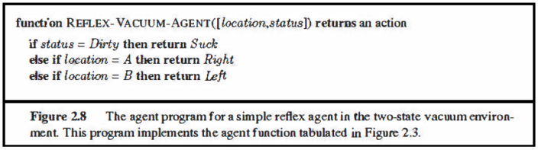

Now suppose you can use one more action “NoOp” which does nothing.

1. Would it be desirable to use this action in this agent program to prevent vacuum cleaner from moving after all squares are cleaned? If yes, modify the simple reflex agent program adding “NoOp” action and if not give an argument that despite the option of “NoOp” the agent is bound to keep moving. [4]

Answer: No, it won’t be good to add NO-ops in the environment as if we want to add the NO-Ops option we need to introduce some memory to check both the locations are clean and if we add memory simple reflex agent is not capable to store memory as it only takes one location as input.

1. If you have a choice of using other type of agents, which one would you choose and how would it prevent vacuum from moving after all squares are cleaned? [3]

Answer: Multiagent would be good to use for using No-ops option as it will check if another location is clean then it will use No-ops option while it will move to another location.